Assignment two - Quiz

Brian Geragthy – s00077881

Fergal Gaffney – s00147036

Web Development & Creative Media Y2

26/04/2015

ASSIGNMENT TWO - QUIZ

# Changes between the previous version and this one.

* Added full Database system – All data is now being stored and read from a database (see Description of Database Functionality).
* Removed Add Quiz functionality (see description of known problems).
* Added user history page (viewable by clicking previous attempts from the quiz finish page). This show a complete summary of the users history. The list has a filter which allows a user to select all quizzes or an individual quiz. The page also features a chart which is a visual representation of the data on the page.
* The site now supports any number of questions in a quiz (previously only 6 were supported). A test quiz can be found under the General Knowledge category (10 question quiz).
* Session Timeout set to 20mins.(To allow people time to view results)
* Small Fixes (Feedback sheet)
  1. Removed “for=”usr” in text box.
  2. Included css, and js folders in project.
  3. Added some instructions to try and make the quiz easier to use.

# Description of database functionality

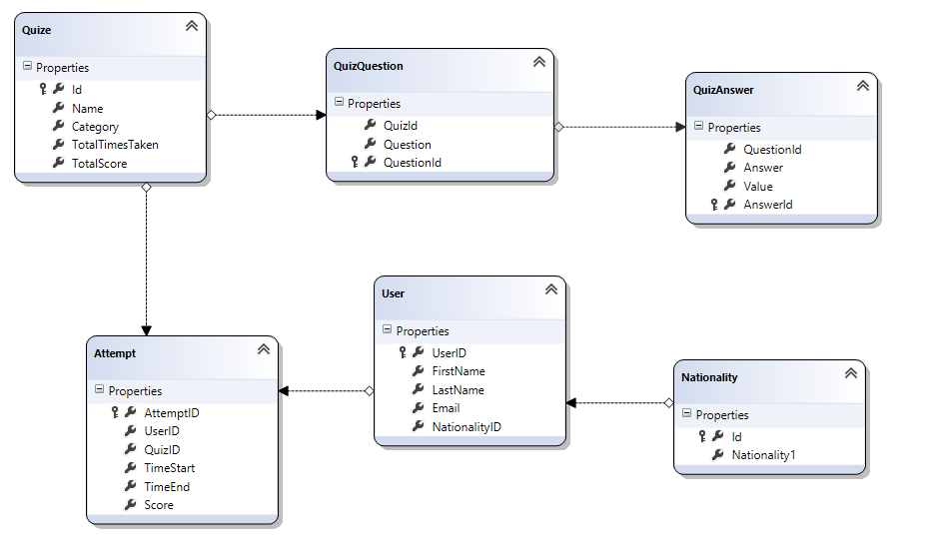

Figure - E.R.D

* All data is now being stored in the database (previously text files).
* We used a dbml model and most of the reads and writes are done with linq. This made some of the more complicated query’s easier to write. The Nationality dropdown on the login page is populated with a sqlDataSource.

# Description of known problems

* If the user selects the same quiz twice in a row and the quiz is still in the session and the question falls in the same order as the previous attempt the answer will be populated. Discovered late so no time to fix.
* If a user signs up with an email that already exists in the database the user information will be loaded in the session (ignoring the new information entered by the user). This is not a BUG. If we refused the user if the email existed it would mean a user could only login once. This system in real life would have a login system as well. For this project we didn’t bother with login and left it as it was.
* We removed the ability for a user to add a quiz. This was done as it was proving difficult to store the data with the current classes we have.

# Lessons learnt

Better planning